1. We needed to normalize the data to have better processing by subtracting the average of the dataset and dividing by the standard deviation of the dataset.
2. I chose my network by trying several layered networks by three different concurrent computers with the same reg and epochs and learning rate but different architecutes. The architecture in the “ML3 ipynb” came up with the better ACCR, so I started changing the lr and reg to find the best architecture and stopped when I reached a sufficient percentage.

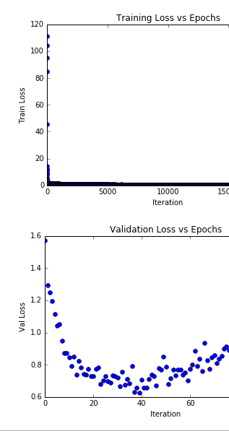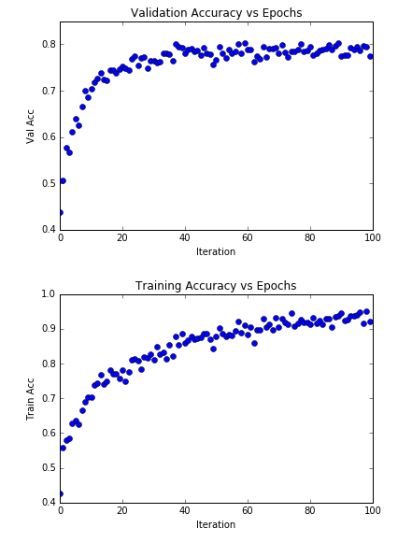

1. The average accuracy (ACCR) of the CNN of my own implementation was 78.4%. My Keras implementation got me an 90.66% accuracy. Thus, the average ACCR is 84.53%.

NP: The data for all these graphs are all located in the ML3 Scratch jupyter file.